Project Design Phase-II
Data Flow Diagram & User Stories
Date | 20 FEB 2026
Team ID | LTVIP2026TMIDS78860
Project Name | Calculating Family Expenses using Service Now
Maximum Marks | 4 Marks

Data Flow Diagrams:
The Data Flow Diagram (DFD) for “Calculating Family Expenses using ServiceNow” represents the logical flow of information within the system. It illustrates how data moves between users, processes, and data stores in the application. The system primarily involves three key actors — Family Members, Finance Admin, and the ServiceNow Platform. Family members enter their individual expense details such as food, bills, transport, and entertainment through a custom expense form in the ServiceNow portal. These details are processed by the Expense Management Module, which validates, categorizes, and stores the data in the Expense Item Table and Expense Category Table. The Finance Admin reviews the consolidated data, analyzes spending trends, and generates budget reports using ServiceNow dashboards. The Budget Table stores predefined monthly or yearly budget limits, which are compared against actual expenses to calculate the remaining balance and identify overspending patterns. The DFD ensures transparency, automation, and accuracy in tracking household financial activities while reducing manual calculations.
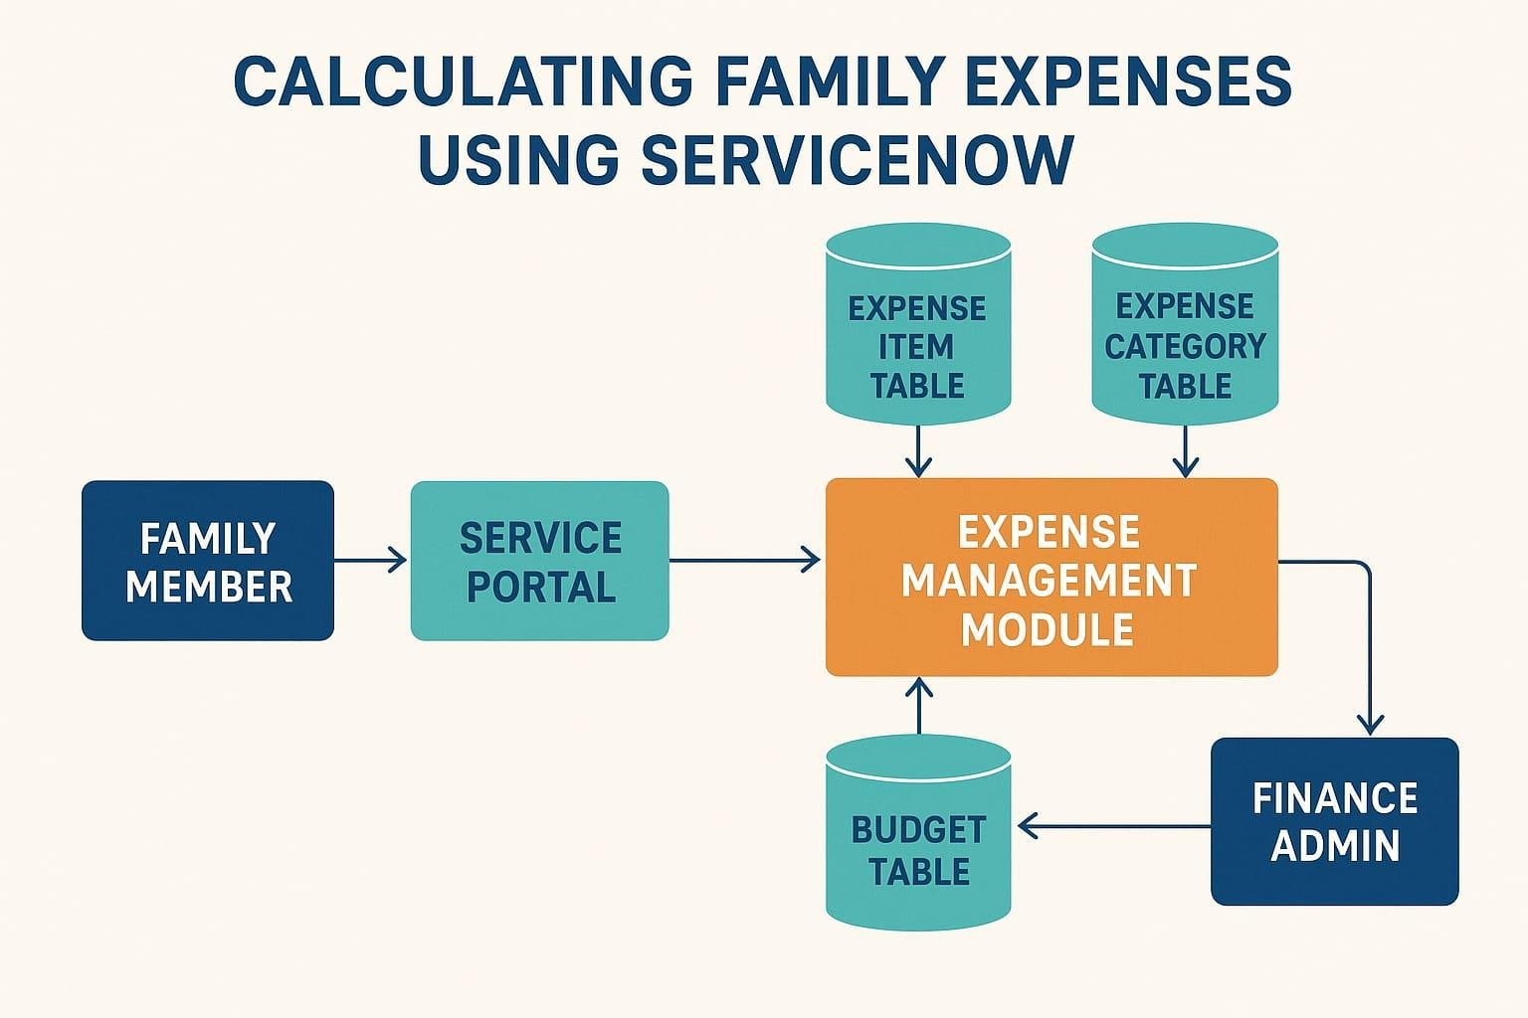
User Stories:
In the Calculating Family Expenses using ServiceNow system, user stories are designed to represent the needs and goals of different users interacting with the platform. As a Family Member, I want to easily record my daily expenses through a simple ServiceNow form so that I can track how much I spend on different categories like food, transport, and entertainment. As a Finance Admin, I want to view and manage all family expenses in a centralized dashboard so that I can analyze spending patterns, compare them with the set budget, and identify areas of overspending. As a System Administrator, I want to ensure that all expense data is stored securely in the ServiceNow database and that automated workflows validate the data to prevent errors. These user stories collectively ensure that the system provides an intuitive, automated, and reliable experience for managing household budgets efficiently.

User Type | Functional  Requirement  (Epic) | User  Story  Number | User Story / Task | Acceptance Criteria | Priority | Release
Family Member | Record Daily Expenses | US-01 | As a family member, I want to add my daily expenses using a simple ServiceNow form so that I can track my spending. | The user can successfully submit expense entries through the form and see them reflected in the expense list. | High | R1
Family Member | Categorize Expenses | US-02 | As a family member, I want to categorize my expenses (e.g., Food, Transport, Utilities) so that I can understand where most of my money is spent. | Expenses are automatically sorted under the correct categories. | Medium | R1
Finance Admin | View Expense Reports | US-03 | As a finance admin, I want to view detailed reports and dashboards so that I can analyze total spending trends. | The system generates reports with accurate totals and visual charts for each category. | High | R1
Finance Admin | Set Monthly Budget | US-04 | As a finance admin, I want to view detailed reports and dashboards so that I can analyze total spending trends. | The system allows budget entry and automatically flags categories exceeding the limit. | High | R2
Finance Admin | Receive  Notifications | US-05 | As a finance admin, I want to receive automatic notifications when expenses exceed a set budget limit. | Notifications are triggered immediately when the budget threshold is crossed. | Medium | R2
System Admin | Manage User Access | US-06 | As a system admin, I want to manage access roles and permissions so that only authorized users can view or modify expense data. | Only authorized users can access and edit expense or budget data. | High | R1
System Admin | Data Validation & Security | US-07 | As a system admin, I want to ensure all expense data is validated and securely stored in the ServiceNow database. | All submitted data passes validation checks and is stored securely without loss or corruption. | High | R1

